ELEC362 - Week 10

Practical Exercises
- Modify the mouse locator application such that it displays the average of all the positions at which the mouse is clicked. You can validate your application by clicking few times on a single place and observing the displayed coordinates converging to a constant value. Start from the source code provided in the lecture

Hint: Use a QVector container (https://doc.qt.io/qt-6/qvector.html) to save all the positions of the QMouseEvent objects, then implement a function to average the coordinates over all objects.

- Implement the colour change functionality in the text formatting app, follow the same steps as done for the size functionality in the lecture. Start from the source code provided in the lecture.

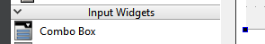
Hints:
Create a dialog with a combo Box

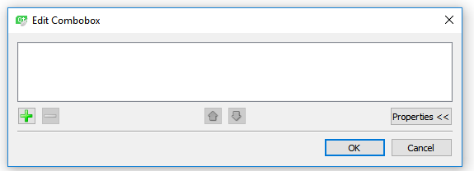
Double click on the combo box widget, then add options to be chosen from the menu (the names of three colours)

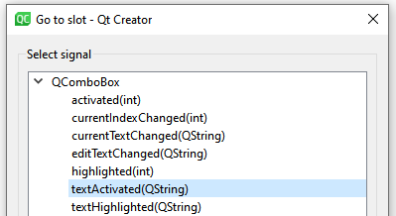
Right click on the combo box widget-> Go to Slot->

The choice of the user will be saved in a variable called “arg1”, use a switch-case to set the font of the colour. You can use colours in Qt by using enumerators in Qt namespace (https://doc.qt.io/qt-6/qt.html#GlobalColor-enum).

- Starting from the “StudentData” project files, first check the main function cpp file as I added some notes there. Then update the code in “studentdata.cpp” to read the student ID number from the Ui and handle the error if the input data is not valid to be a student ID. The application should show a message box explaining to the user that the entered student ID is not valid.

After that, add the “University of Liverpool” figure to your project as a resource file, then plot it on the Ui by implementing paintEvent() function. The figure should be located on the empty upper part of the dialog.

Finally using the signal-slot mechanism, connect the “cancel” button to the close sign on the corner of the dialog, such that when cancel is pressed, the dialog closes.

Hint: Define the figure as a QPixmap item and use the function drawpixmap() to draw it on the Ui.

